**DATA ANALYTICS BASED**

**RETAIL STORES STOCK INVENTORY ANALYTICS**

**REPORTS**



**BY**

**PNT2022TMID52083**

**Y.CHRISTY JELIN**

**V.BHARATHI**

**M.BANU**

**C.KUMARESAN**

**Project Report**

**1. INTRODUCTION**

1.1 Project Overview

1.2 Purpose

**2. LITERATURE SURVEY**

2.1 Existing problem

2.2 References

2.3 Problem Statement Definition

**3. IDEATION & PROPOSED SOLUTION**

3.1 Empathy Map Canvas

3.2 Ideation & Brainstorming

3.3 Proposed Solution

3.4 Problem Solution fit

**4. REQUIREMENT ANALYSIS**

4.1 Functional requirement

4.2 Non-Functional requirements

**5. PROJECT DESIGN**

5.1 Data Flow Diagrams

5.2 Solution & Technical Architecture

5.3 User Stories

**6. PROJECT PLANNING & SCHEDULING**

6.1 Sprint Planning & Estimation

6.2 Sprint Delivery Schedule

6.3 Reports from JIRA

**7. CODING & SOLUTIONING (Explain the features added in the project along with code)**

7.1 Feature 1

7.2 Feature 2

7.3 Database Schema (if Applicable)

**8. TESTING**

8.1 Test Cases

8.2 User Acceptance Testing

**9. RESULTS**

9.1 Performance Metrics

**10. ADVANTAGES & DISADVANTAGES**

**11. CONCLUSION**

**12. FUTURE SCOPE**

**13. APPENDIX**

Source Code

1. **INTRODUCTION**
   1. Project Overview

As retail market becomes extensively competitive, the ability to optimizing serving business processes while satisfying customer expectations has never been more important. Therefore, managing and channelizing data to work towards customer delight as well as generate healthy profits is crucial to survive prosperously. In the case of big retail players internationally as well as in India, data or rather big data analytics is now being applied at every stage of the retail process - tracking emerging popular products, forecasting sales and future demand through predictive simulation, optimizing product placements and offers via customer heat-mapping and many more. Alongside this, identifying the customers likely to be interested in particular product types based on their previous purchase behaviors, working out the best way to approach them through targeted marketing efforts and finally working out what to sell them next is what forms the core of data analytics. This article is the outcome of a descriptive research on the past, present and future of retail industry and the application of business analytics in shaping appropriate marketing strategies.

1.2Purpose

Analytics is the discovery and communication of meaningful patterns in data. As a topic, analytics has found its way from being discussed at the sidelines of industry and technology conferences, to the top of the corporate agenda. With the existing promise of delivering performance improvements not seen since the redesign of core processes in the 1990s, these tools are likely to change the competitive landscape in many industries in the years to come. Big Data is all about the non-traditional ways of dealing with the modern digital data. We exist in an ocean of digital data. It includes data stored in piles of well-structured databases residing with organizations, streams of data generated from the dynamic social networks, various understandable and in signals generated by all kinds of digital equipment all over the place. For an organization, Big Data can be about identifying the right datasets from large amount of data commonly defined by the three Vs - Volume, Velocity and Variety; transforming them into readily consumable models; and then extracting meaningful insights for devising business strategies. These insights can be used to improve different aspects of the business - from marketing and sales, to research and operations, and customer services. Big Data enables clients in the retail Industry to track and better understand a variety of information from many different sources like CRM, inventory management system, emails, transactional data, sensors data etc. Industry can identify the current trends, re-order supplies for hot-selling items, adjust the prices in real time and also manage and control product distribution across different stores to their sales in more effective manner. This provides retail industry with entirely different perspectives of looking towards the datasets available at their disposal. By collating these organizational datasets with social media data streams, they can also use it for better sales predictions, designing relevant campaigns to suit their profitable customers and thereby ensuring customer satisfaction.

1. **LITERATURE SURVEY**

2.1Existing Problem

The term “Big Data” has recently been applied to datasets that grow so large that they become awkward to work with using traditional database management systems. They are data sets whose size is beyond the ability of commonly used software tools and storage systems to capture, store, manage, as well as process the data within a tolerable elapsed time [12]. Big data sizes are constantly increasing, currently ranging from a few dozen of data in a single data set. Consequently, some of the difficulties related to big data include capture, storage, search, sharing, analytics, and visualizing. Today, enterprises are exploring large volumes of highly detailed data so as to discover facts they didn’t know before [17].Hence, big data analytics is where advanced analytic techniques are applied on big data sets. Analytics based on large data samples reveals and leverages business change. However, the larger the set of data, the more difficult it becomes to manage [17].In this section, we will start by discussing the characteristics of big data, as well a sites importance. Naturally, business benefit can commonly be derived from analyzing larger and more complex data sets that require real time or near-real time capabilities; however, this leads to a need for new data architectures, analytical methods, and tools. Therefore the successive section will elaborate the big data analytics tools and methods, In particular, starting with the big data storage and management, then moving on to the big data analytic processing. It then concludes with some of the various big data analyses which have grown in usage with big data.

2.2Reference

1. Adams, M.N.: Perspectives on Data Mining. International Journal of Market Research

52(1), 11–19 (2010)

2. Asur, S., Huberman, B.A.: Predicting the Future with Social Media. In: ACM International

Conference on Web Intelligence and Intelligent Agent Technology, vol. 1, pp. 492–499

(2010)

3. Bakshi, K.: Considerations for Big Data: Architecture and Approaches. In: Proceedings of

the IEEE Aerospace Conference, pp. 1–7 (2012)

4. Cebr: Data equity, Unlocking the value of big data. in: SAS Reports, pp. 1–44 (2012)

5. Cohen, J., Dolan, B., Dunlap, M., Hellerstein, J.M., Welton, C.: MAD Skills: New Analysis

Practices for Big Data. Proceedings of the ACM VLDB Endowment 2(2), 1481–1492

(2009)

6. Cuzzocrea, A., Song, I., Davis, K.C.: Analytics over Large-Scale Multidimensional Data:

The Big Data Revolution! In: Proceedings of the ACM International Workshop on Data

Warehousing and OLAP, pp. 101–104 (2011)

7. Economist Intelligence Unit: The Deciding Factor: Big Data & Decision Making. In:

Capgemini Reports, pp. 1–24 (2012)

8. Elgendy, N.: Big Data Analytics in Support of the Decision Making Process. MSc Thesis,

German University in Cairo, p. 164 (2013)

9. EMC: Data Science and Big Data Analytics. In: EMC Education Services, pp. 1–508

(2012)

10. He, Y., Lee, R., Huai, Y., Shao, Z., Jain, N., Zhang, X., Xu, Z.: RCFile: A Fast and Spaceefficient

Data Placement Structure in MapReduce-based Warehouse Systems. In: IEEE

International Conference on Data Engineering (ICDE), pp. 1199–1208 (2011)

11. Herodotou, H., Lim, H., Luo, G., Borisov, N., Dong, L., Cetin, F.B., Babu, S.: Starfish: A

Self-tuning System for Big Data Analytics. In: Proceedings of the Conference on Innovative

Data Systems Research, pp. 261–272 (2011)

12. Kubick, W.R.: Big Data, Information and Meaning. In: Clinical Trial Insights, pp. 26–28

(2012)

13. Lee, R., Luo, T., Huai, Y., Wang, F., He, Y., Zhang, X.: Ysmart: Yet Another SQL-to-

MapReduce Translator. In: IEEE International Conference on Distributed Computing

Systems (ICDCS), pp. 25–36 (2011)

14. Manyika, J., Chui, M., Brown, B., Bughin, J., Dobbs, R., Roxburgh, C., Byers, A.H.: Big

Data: The Next Frontier for Innovation, Competition, and Productivity. In: McKinsey

Global Institute Reports, pp. 1–156 (2011)

15. Mouthami, K., Devi, K.N., Bhaskaran, V.M.: Sentiment Analysis and Classification Based

on Textual Reviews. In: International Conference on Information Communication and

Embedded Systems (ICICES), pp. 271–276 (2013)

16. Plattner, H., Zeier, A.: In-Memory Data Management: An Inflection Point for Enterprise

Applications. Springer, Heidelberg (2011)

17. Russom, P.: Big Data Analytics. In: TDWI Best Practices Report, pp. 1–40 (2011)

18. Sanchez, D., Martin-Bautista, M.J., Blanco, I., Torre, C.: Text Knowledge Mining: An Alternative

to Text Data Mining. In: IEEE International Conference on Data Mining Workshops,

pp. 664–672 (2008)

19. Serrat, O.: Social Network Analysis. Knowledge Network Solutions 28, 1–4 (2009)

20. Shen, Z., Wei, J., Sundaresan, N., Ma, K.L.: Visual Analysis of Massive Web Session Data.

In: Large Data Analysis and Visualization (LDAV), pp. 65–72 (2012)

21. Song, Z., Kusiak, A.: Optimizing Product Configurations with a Data Mining Approach.

International Journal of Production Research 47(7), 1733–1751 (2009)

22. TechAmerica: Demystifying Big Data: A Practical Guide to Transforming the Business of

Government. In: TechAmerica Reports, pp. 1–40 (2012)

23. Vander Valk, T., Gijsbers, G.: The Use of Social Network Analysis in Innovation Studies:

Mapping Actors and Technologies. Innovation: Management, Policy & Practice 12(1),

5–17 (2010)

24. Zeng, D., Hsinchun, C., Lusch, R., Li, S.H.: Social Media Analytics and Intelligence.

IEEE Intelligent Systems 25(6), 13–16 (2010)

25. Zhang, L., Stoffel, A., Behrisch, M., Mittelstadt, S., Schreck, T., Pompl, R., Weber, S.,

Last, H., Keim, D.: Visual Analytics for the Big Data Era—A Comparative Review of

State-of-the-Art Commercial Systems. In: IEEE Conference on Visual Analytics Science

Technology (VAST), pp. 173–182 (2012)

2.3Problem Statement Definition

**Customer problem statement template:**

Create a problem statement to understand your customer’s point of view. The customer problem statement template helps you focus on what matters to create experiences people will love. A well- articulated customer problem statement allows you and your team to find the ideal solution for the challenges your customers face. Throughout the process, you’ll also be able to empathize with your customers, which helps you better understand how they perceive product or service.

Reference**:**https://micro.com/templates/customer-problem-statemnet/

**Example:**

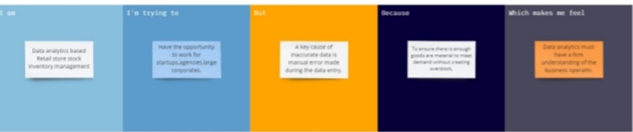

1. **IDEATION & PROPOSED SOLUTION**
   1. Empathy Map Canvas

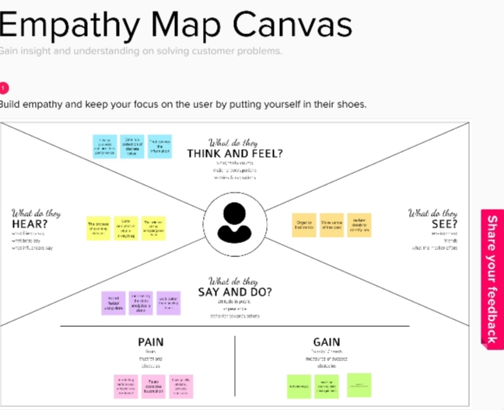

3.2Ideation & Brain storming

**Brainstorm & idea prioritization Template:**

Brainstorming provides a free and open environment that encourages everyone within a team to participate in the creative thinking process that leads to problem solving. Prioritizing volume over value, out- of- the- box ideas are welcome and built upon, and all participants are encouraged to collaborate, helping each other develop a rich amount of creative solutions.

Use this template in your own brainstorming sessions so your team can unleash their imagination and start shaping concepts even if you’re not sitting in the same room.

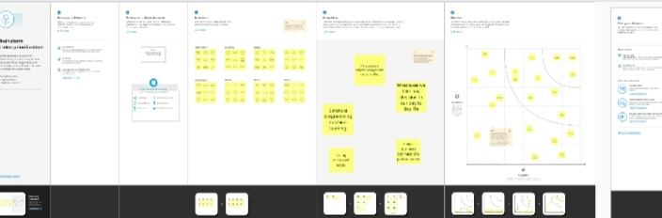

3.3Proposed Solution

|  |  |  |
| --- | --- | --- |
| **S.NO** | **PARAMETER** | **DESCRIPTION** |
| 1. | Problem Statement (Problem to be solved) | Unclear communication, Inadequate access, Inefficient warehouse management, overselling, Spoiled goods. |
| 2. | Idea / Solution description | Automation access control, the future and top performer of commerce tech, technology innovation is something that can real help. |
| 3. | Novelty / Uniqueness | Novelty detection is a statistical method used to determine new or unknown data. A measure of unwanted existing within the system. |
| 4. | Social Impact / Customer Satisfaction | Industry cloud solution for retail, one rail last mail delivery fulfilment. Always ask for feedback, Respond to customer reviews. |
| 5. | Business Model (Revenue Model) | SAP has supported the retail industry for almost five decades. providing fundamental solution a single view of the business finance to customer experience |
| 6. | Scalability of the Solution | Scalability is the measures sales monitor individual store forecast control access optimize staff scheduling bench mark performance |

3.4 Problem Solution Fit

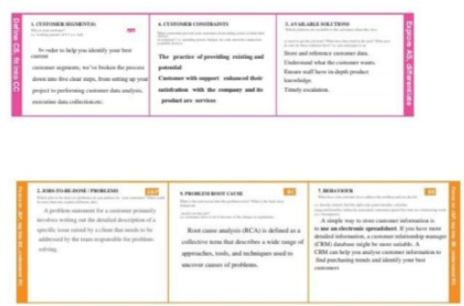

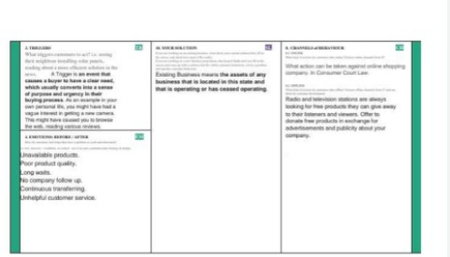

1. **REQUIREMENT ANALYSIS**
   1. Functional Requirement

An analytics framework that retailers can use to structure their programmer consists of four areas namely, merchandising, marketing, supply chain and store operations

**Merchandising Analytics:**

Retailers can use merchandising analytics to stock the right product at the right place at the right time. Merchandising analytics enable planners to align their merchandising decisions with customer expectations. The key areas of merchandising analytics are assortment planning, product adjacency and space allocation. Analytics holds the key to optimizing assortment. For each stock keeping unit (SKU), retailers can identify a few attributes, such as brand, package size, are meaningful to customers. They can then use the sales of existing SKUs to estimate the future demand at attribute level and further use these estimates to forecast the demand for any combination of attributes. Analytics lets retailers discover new products that have high chances of selling well, the report says.

**Marketing Analytics:**

To keep up with changing customer demands and ensure loyalty, retailers need marketing analytics for deeper customer insight, targeted interactions and improved customer service. Marketing analytics quickly combine all relevant customer data - from point of sale (POS) systems, customer relationship management (CRM) system, loyalty cards, etc., with social media data - perform sophisticated analytics, and share insights to help optimize marketing decisions. It can also help to optimize multichannel performance, improve marketing effectiveness and enhance social media presence.

**Supply Chain Analytics:**

Retail profitability is directly impacted by the logistics efficiency to maximize demand and avoid any back orders or stock-outs. These include interventions in logistics, inventory and supplier performance. Advanced analytics solutions using a global positioning system (GPS) can help in tracking the movement of the fleet, understanding the behaviors of the drivers, identifying hazard points on the routes, etc. This can help in reducing the overall costs, make logistics safer and efficient.

**Store Operation Analytics:**

More and more retailers are adding sensors to people, places, processes and products in order to gather and information for better decision-making and greater transparency. Predictive analytics applications process this data, optimize the supply chain and decrease inventory shrink. Retail stores are increasingly adopting sensors to determine inventory levels and restock shelves automatically. Location analytics can map how customers move through a store. Using a combination of IoT (Internet of Things) - enabled product and shelf sensors, cameras and RFID (Radio Frequency Identification) devices, one can track which sections of the store receive the most traffic in general over different hours of the day and week. Going forward, retailers can view IOT as a tool that enables them to help their customers through innovations such as smart price tags that can change prices in real time, mirrors that allow a person to try clothes on virtually, and packaging that monitors the freshness of goods and alerts the consumer when they are nearing the end of their shelf life.

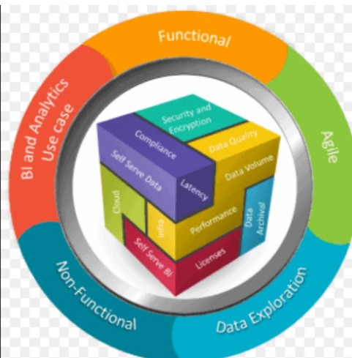

4.2Non Functional Requirement

Retailers have already started putting data analytics at the heart of their operations across the value chain - procurement, supply chain, sales and marketing, store operations, and customer management. However, they now need to establish a big data ecosystem, which processes multiple terabytes of new data, which will help them improve their revenues via analytics-based decision-making. While this may sound really exciting, big data management and analysis comes with its own set of challenges. Several issues will have to be kept in mind to optimize the full capabilities of big data. Privacy, security, intellectual property, and even liability policies need to be stringent in terms of big data. Since big data encapsulates high end analytics, specially trained professionals need to be added to the team to utilize and functionalize the big data. Companies need to integrate information from multiple data sources, often from third parties, as well as deploy an efficient data to aid such an environment. Many times companies fall in shortsightedness, failing to implement insights from analytics. However, this could be fixed by continuous alterations of retail styles where a certain team is allotted for task of arrangement of insights and their implementation.

1. **PROJECT DESIGN**
   1. Data Flow Diagram

Data Flow Diagrams:

A Data Flow Diagram (DFD) is a traditional visual representation of the information flows within a system. A neat and clear DFD can depict the right amount of the system requirement graphically.

It shows how data centers and leaves the system, what changes the information, and where data is stores.

Solution architecture is a complex process –with many sub processes – that bridges the gap between business problems and technology solutions. Its goals are to:

* Customers, who interact with the merchant online, with pickup or delivery,or physically at the stores ,whether it is by interaction with a store employee.

* Store managers, who want to have visibility onto how products and product categories are selling, get predictive insights such as inventory consumption and drive automatic actions.
* Upper management, who is interested in advanced real-time analytics with• visualization reporting and AI capabilities.
* One of the main complexities of the retail business is the multiplicity of system and data models

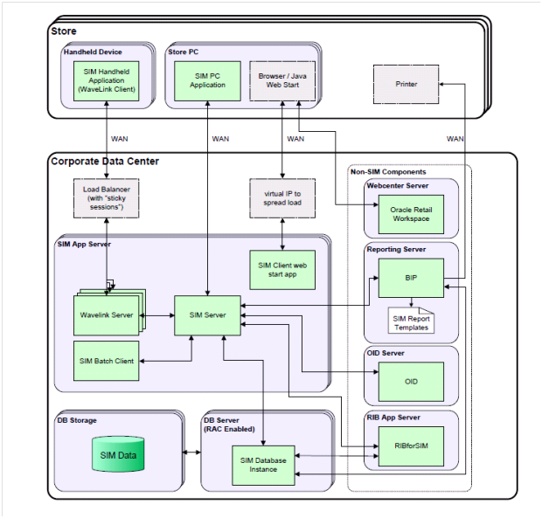

* 1. Solution& Technical Architecture

|  |  |  |  |
| --- | --- | --- | --- |
| S. No | Component | Description | Technology |
| 1. | Collecting data | Data collection is the process of gathering and measuring information on variables of interest. | Mobile phones, GPS, Bluetooth, Smart cards. |
| 2. | Data analysis | A data analytics collects and stores data on market research, logistics, linguistics, or other behaviors. | Data analysis is the process of examining data sets in order to find trends and draw conclusions about the information they contain. |
| 3. | Reporting results | A report result is a document that presents information in an organized format for a specific audience and purpose. | Fault detection, monitoring and maintenance technology used by computers. |
| 4. | Improving Processes | Identify, plan and implement key projects to improve quality ,reduce costs, increase productivity and improve cycle time by reducing wasted time, etc. | Process mining ,Robotic Process Automation, Data Extraction, Further Reading |
| 5. | Building a data driven culture | It makes strategic decisions based on data analysis and interpretation. | Lay your data foundation, turn data into action, monitor and refine your data culture. |
| 6. | Product | A product description is the marketing copy that explains what a product is and why it’s worth purchasing. | Television, Internet, Cell phones , computers, software. |
| 7. | Price | Price the amount of money that has to be paid to acquire a given product. | Ending a price with money that has to be paid to acquire a given product. an odd number to make a customer feel like they are spending much less. |
| 8. | Place | Start early, Be specific, Use unfamiliar locations. | Virtual Fitting Rooms, Cashierless checkout, Total Experience. |
| 9. | Promotion | Variety of action intended to raise greater awareness or advancement of an item. | Promotion technology offers up 120Hz refresh rate instead of the standard 60Hz. |

* 1. User Stories

|  |  |  |  |  |  |  |
| --- | --- | --- | --- | --- | --- | --- |
| **User Type** | **Functional Requirement(Epic)** | **User story number** | **User story/ task** | **Acceptance criteria** | **priority** | **Release** |
| Customer (Mobile user) | Registration | USN-1 | I can register for the application | I can access my account | High | Sprint1 |
| Customer(Web user | Login | USN-2 | Entering my email, password | Dashboard | High | Sprint1 |
| Customer care executive | Dashboard | USN-3 | Confirming password | I can receive confirmation | Low | Sprint2 |
| Administrator | Data management | USN-4 | I will receive confirmation email | Email | Medium | Sprint1 |
| Chaotic | Data querying | USN-5 | I have register for the application | Click confirm | High | Sprint1 |
| Reactive | Reporting | USN-1 | I can register for the application | I can register | Medium | Sprint1 |
| Defined | Mobile BI | USN-2 | Through feedback | Access the dashboard | Low | Sprint1 |
| Managed | IOT analytic | USN-2 | I can log into the application | Face book login | Medium | Sprint2 |
| Optimized | Embedded analytics | USN-4 | Entering email& password |  | High | Sprint2 |

1. PROJECT PLANNING& SCHEDULING
   1. Sprint planning& Estimation

**Identifying and creation of Client Profiles:**

Today retailers have a better way to identify the customers and offer them the right product. The customer segmentation is now much more refined and data driven based on customers transaction history, basket analysis, loyalty programs, social media interactions. Big Data management segment buyer’s data to create personality points, demarcating faceless mass into slots, through studying their purchases. Transaction reports and loyalty plans are combed through, to bring out relevant data and action on it. It is easier for retailers to get a 360 degree view of the customer and offer them customized products based on their past preferences or what people similar to them are buying.

**Price Optimization:**

Online retailing is based on dynamic pricing and the price of a product depends on multiple factors from market demand, inventory, competitors pricing, whether a particular product is the seasons must have product, etc. Data Analytics plays a vital role in determining the pricing. Algorithms track demand, inventory levels, and competitor activity and automatically respond to market changes in real time, allowing action to be taken based on insights in a time saving manner. It helps in determining when prices should be dropped – commonly known as ‘mark down optimization’. Prior to the age of analytics most retailers would just reduce prices at the end of a buying season for a particular product line, when demand has almost gone. But now based on Machine Learning, prices are adjusted real time and recommendations or offers are sent to a specific set of customers who has purchased those products or has earlier shown interest to buy those.

**Generating Customer Loyalty:**

Customers today need to be treated royally, they want retailers to understand their requirement, recommend product and services that suits them, and keep them informed at every stage of the selling cycle from booking, shipping, and product delivery to feedback. This is not an easy task for the retailers keeping in mind the varied customers they serve. Big Data Analysis can help them to recommend the right products to a customer or come up with targeted marketing campaigns to reach out to a specific segment. It also helps you to understand the customers’ path to purchase or their buying pattern, thus reaching out to them at each step to close the sales cycle.

**Predicting Demand:**

Today retailers have advanced tools available to them in order to know the trends in the industry. Forecasting demand has become much more efficient now and retailers can easily find if a particular product is in demand during certain time of the year, or in a particular city or by a specific group and how to adjust the inventory. Retailers also gather a lot of data from social media to understand the changing preferences of customers or do sentiment analysis to find whether the product is getting positive, negative or neutral feedback in the market.

**Inventory Management:**

Trend forecasting algorithms sort through the buying data to analyze what marketing departments need to promote and what not. Once the retailers get a deep insight into buying trends of the customers, they focus on the sectors where there will be high demand. This involves gathering demographic, seasonal, occasions led data and economic indicators to build a picture of purchase behavior across the targeted market. This really helps in inventory management in a better way.

**Identify the highest ROI Opportunities:**

Each customer interaction can have a large impact on existing or potential relationships. Rolling out a new idea to the whole sales force is a risky endeavor, as a wrong decision could lead to immediate as well as prolonged loss of profit. Instead, leading business organizations have found that the best way to isolate the cause and-effect relationship between any strategic shift and key performance indicators through use of a test-and-learn approach – trying an idea with some sets of customers and comparing the performance of the ‘test’ group to the performance of a well-matched ‘control’ group. After having a better understanding of their current and potential customer base, retailers use predictive risk filters and data-driven intelligence to model expected responses in marketing campaigns, as measured by propensity to buy / likely to buy.

**Fraud Detection:**

Big Data Analytics can be effectively used to detect any fraud by analyzing data from daily transactions and activities such as purchasing, accounts payable, sales projections, employee shift records, returns and store-level video and audio recordings.

6.2Sprint Deliverable

Analytics plays an important role for marketers as they work to achieve the goal of understanding customers. Mobile devices have a prominent place in the expanding Internet of Things (IoT) ecosystem, and businesses shall be leveraging analytics to collect the rich data they provide. Once consumers have agreed to “opt in,” retailers can learn quite a bit from how they use their devices to interact with a brand. For example, what products are they most interested in browsing and buying? How often are made and are there developing patterns? If a shopper is buying the same box of baby diapers once every two weeks, for example, they might appreciate a reminder to buy, notifications of sales or an automated purchase renewal option. Analytics give retailers the power to identify these patterns and adjust their offerings to better cater to users, in turn enhancing the convenience, customization and commerce of mobile shopping. The value, variety and velocity of retail data is surging by the day, making it imperative for the industry players to elevate their offerings to match the changing consumer paradigms. While consumers may be tilting between the widely growing network of e-tailing and traditional brick and mortar stores, it’s the innate charm of providing a personalized experience that still draws consumers to ground zero. However, times are e-changing and gone are the days of long-term business planning. With technology paving its way deep into the sector, it has become crucial to transform or else perish. The traditional retails stores are left with no choice but to be a part of the change and make a dash for a multitude of reforms to give attract, retain and widen their consumer base. With understanding the consumer forming the basis of every business strategy, it becomes the demand of the industry to scale up data collection, analytics and its usage. A McKinsey report had suggested that retailers making use of big data analytics could increase their operating margins by as much as 60 per cent. The tremendously competitive retail environment has made it extremely complicated to understand and win consumers. The roadblock does not exist in the unavailability of data defining the consumers and their buying patterns, rather its availability in large volumes. The biggest challenge is to fathom and interpret the data procured from a variety of channels to take informed business decisions. And this is by far the biggest challenge given the plethora of tools available to analyze and report on data that may not give deep decision making insights unless rightly interpreted and aligned to the business goals.

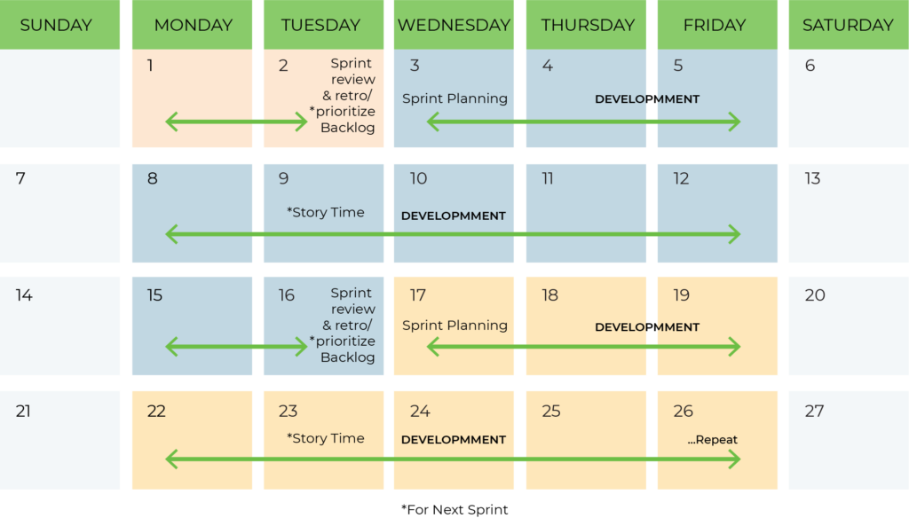

6.3 Reports from JIRA

JIRA offers reporting in a number of different formats. Project reports that are available from the home screen of the selected project, Gadgets that can be added and arranged in Dashboards and for each filter, the issue navigator offers various output formats that can be used in third party reporting software. Additionally, we will mention some advanced methods that customers have been using.

**Standard Reports**

In JIRA, a project will automatically offer standard reports available to the user without any necessary configuration. These standard reports comprise a wide range of reporting applications such as time tracking, workload and also abstract reports like Pie Charts that can be used in various ways

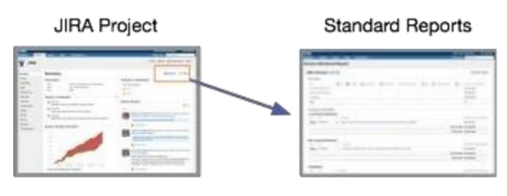

* **CODING & SOLUTIONING (Explain the features added in the project along with code)**

7.1 Feature 1

**Purpose of Having Coding Standards:**

* A coding standard gives a uniform appearance to the codes written by different engineers.
* It improves readability, and maintainability of the code and it reduces complexity also.
* It helps in code reuse and helps to detect error easily.
* It promotes sound programming practices and increases efficiency of the programmers

**1.Limited use of globals:**

These rules tell about which types of data that can be declared global and the data that can’t be.

**2. Standard headers for different modules:** For better understanding and maintenance of the code, the header of different modules should follow some standard format and information. The header format must contain below things that is being used in various companies:

* Name of the module
* Date of module creation
* Author of the module
* Modification history
* Synopsis of the module about what the module does
* Different functions supported in the module along with their input output parameters
* Global variables accessed or modified by the module

**3. Naming conventions for local variables, global variables, constants and functions:**

Some of the naming conventions are given below:

* Meaningful and understandable variables name helps anyone to understand the reason of using it.
* Local variables should be named using camel case lettering starting with small• letter (e.g. local Data) whereas Global variables names should start with a capital letter (e.g. Global Data). Constant names should be formed using capital letters only (e.g. CONSDATA).
* It is better to avoid the use of digits in variable names.
* The names of the function should be written in camel case starting with small letters.
* The name of the function must describe the reason of using the function clearly and briefly.

**4. Indentation:**

Proper indentation is very important to increase the readability of the code. For making the code readable, programmers should use White spaces properly. Some of the spacing conventions are given below:

* There must be a space after giving a comma between two function arguments.
* Each nested block should be properly indented and spaced.
* Proper Indentation should be there at the beginning and at the end of each block in the program.
* All braces should start from a new line and the code following the end of braces also start from a new line.

**5. Error return values and exception handling conventions:**

All functions that encountering an error condition should either return a 0 or 1 for simplifying the debugging.

7.2 Feature 2

**Advantages of Coding Guidelines:**

* Coding guidelines increase the efficiency of the software and reduces the development time.
* Coding guidelines help in detecting errors in the early phases, so it helps to reduce the extra cost incurred by the software project.
* If coding guidelines are maintained properly, then the software code increases readability and understandability thus it reduces the complexity of the code.
* It reduces the hidden cost for developing the software.

1. **Avoid using a coding style that is too difficult to understand:**

Code should be easily understandable. The complex code makes maintenance and debugging difficult and expensive.

1. **Avoid using an identifier for multiple purposes:**

Each variable should be given a descriptive and meaningful name indicating the reason behind using it. This is not possible if an identifier is used for multiple purposes and thus it can lead to confusion to the reader. Moreover, it leads to more difficulty during future enhancements.

1. **Code should be well documented**:

The code should be properly commented for understanding easily. Comments regarding the statements increase the understandability of the code.

1. **Length of functions should not be very large:**

Lengthy functions are very difficult to understand. That’s why functions should be small enough to carry out small work and lengthy functions should be broken into small ones for completing small tasks.

7.3 Database Schema (if Applicable)

A database schema is an abstract design that represents the storage of your data in a database. It describes both the organization of data and the relationships between tables in a given database. Developers plan a database schema in advance so they know what components are necessary and how they will connect to each other.

**A database schema will include:**

* All important or relevant data
* Consistent formatting for all data entries
* Unique keys for all entries and database objects
* Each column in a table has a name and data type

**Database schema types**

There are two main database schema types that define different parts of the schema: logical and physical.

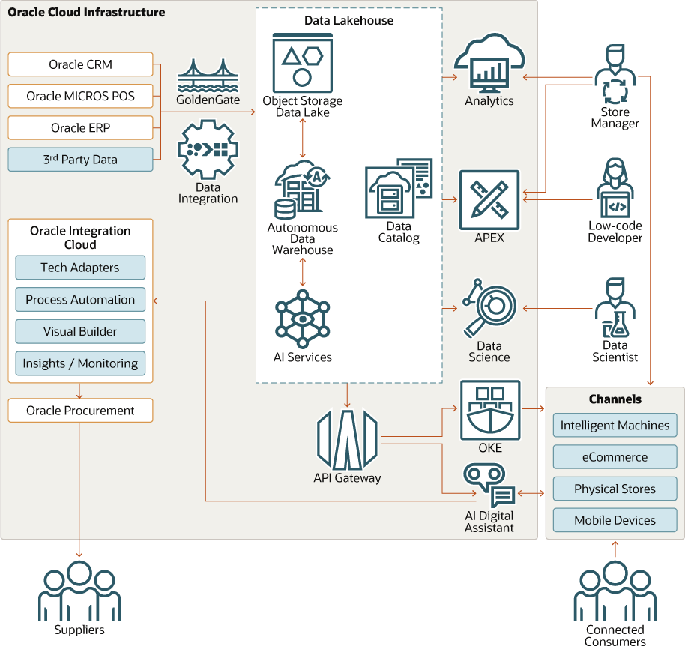

8. TESTING

8.1 Test Cases

In this section, we discuss the computational issues related to the size and complexity of the data files used in each dataset. These considerations include how we solved challenges related to data scale and the variety of files, as well as an assessment of the strengths and weaknesses of our modeling choices.

**Computational Considerations and Demands**

We have already discussed aggregation strategies for dealing with large files (primarily the http files in both datasets). These strategies certainly helped to address computational challenges for dealing with these large files. In addition, we were able to make use of the ARC resources in order to more quickly perform computations on the large data files and our aggregate global datasets. These resources provided a substantial boost in speed over our personal computers. For example, our aggregation code for DTAA’s http info was processing one day of website visits in roughly 5 minutes on John’s laptop, but accelerated to one day of website visits in roughly 15 seconds on ARC. One difficulty related to using ARC resources was the challenge of remote access to these clusters. Connecting via a VPN from the other side of the planet presented substantial latency issues, nearly to the point of un usability. Designing multi-threaded code further provided a speed increase, especially when running code in the ARC environment. Despite the additional complications and debugging involved in ensuring that the code was correct, the performance increase was worthwhile when processing large files. For example, we first worked to aggregate the content of the DTAA http info file by date and user in a single thread. After getting a sense for how long that aggregation would take to execute, we preprocessed that http info file, separating it into one file for each of the 1,000 employees. Then, we updated the code to aggregate keywords for each employee in a separate thread, allowing us to make use of multi-core desktops and ARC clusters. Using Gephi for network graphs was also quite useful, as this software package contains utilities such as filtering, timeline preview, and categorization by label. It also performed efficiently, despite the 1,000 node and 1,300,000 edged graph of email communication that we supplied.

**Computational Modeling Choices**

Our choices of models were impacted by how we aggregated and reduced all of the information provided in both the ACME and especially the DTAA datasets. Since our ideas about the stories themselves were finalized shortly before the deadline, the amount of time available to us to run and refine models was greatly reduced. Rather than fitting a more complicated model before downsizing the data or fitting an over-fitted model that may not predict well, we used approaches that are reliable such as a logistic LASSO and CART. The datasets that we ran models on were aggregated by employees in the company, and thus contained 1,000 observations.

8.2 User Acceptance Testing

Despite working on these datasets for more than two months, nearly all of our best ideas and findings came in the last two days while writing this report, some even in the final 10 hours. This resulted in a massive rewrite of this document in the final hours before the deadline. In addition to demonstrating the benefits of last-minute panic, this shows that moments of inspiration can occur at any time when exploring the data, even at the last moment.

As noted previously, we felt that our exploration of the DTAA dataset was initially biased towards the approach we followed on the ACME dataset. Because the storylines within the companies and datasets were quite different, this caused us issues with detecting the scenarios that we report in this paper.

Lastly, it is important to have items setup even when not all the pieces are finished. When group members have varying schedules and other deadlines to meet, it can be hard to have all the pieces needed in order to analyze something. Having the code ready to go when those pieces are in place would have saved some time.

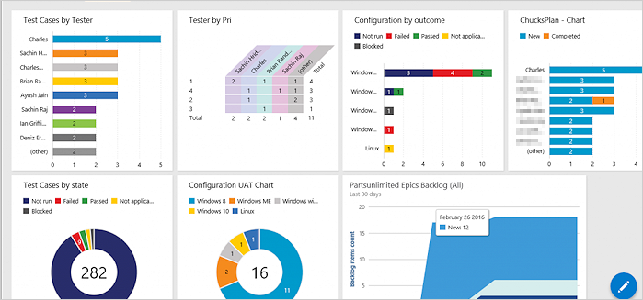

**9. RESULTS**

Retailing is at the platform for more data-driven disruption because the quality of data available from internet purchases, social-network conversations, and recently, location-specific smart phone interactions have emerged into a new entity for digital based transactions. Improved performance, better risk management, and the ability to unearth insights that would otherwise remain hidden, are the benefits organizations reap through utilization of big data management.

Retailers can benefit immensely form a structured analytics-driven approach that will help them understand how their customers are using their products and services, how their operations and supply chain are performing, how to manage their workforce and how to identify key risks - insights that they then can then act upon. The pace and the dexterity with which micro data is collected, gives the retailers immediate insights on the shopping trends. This analysis on the move allows them to adjust their prices and add to the lure by announcing on the spot discounts on the sales floor based on their current and previous shopping patterns. This data, often collected through interactive mobile devices in stores, provides the retailer an understanding of the buyers needs and give insights into making smarter decisions about product placement in the store. Data capture and analytics usage certainly have come a long way in the last ten years, and it is interesting to look back on how trends in data analytics have affected the marketplace. As the Internet of Things expands further and our world becomes even more connected, this space will continue to evolve.

**10. ADVANTAGES& DIS ADVANTAGES**

**Advantages**

* **Data analytics helps an organization make better decisions**

Lot of times decisions within organizations are made more on gut feel rather than facts and data. One of the reasons for this could be lack of access to quality data that can help with better decision making. Analytics can help with transforming the data that is available into valuable information for executives so that better decisions can be made. This can be a source of competitive advantage if fewer poor decisions are made since poor decisions can have a negative impact on a number of areas including company growth and profitability.

* **Increase the efficiency of the work**

Analytics can help analyze large amounts of data quickly and display it in a formulated manner to help achieve specific organizational goals. It encourages a culture of efficiency and teamwork by allowing the managers to share the insights from the analytics results to the employees. The gaps and improvement areas within a company become evident and actions can be taken to increase the overall efficiency of the workplace thereby increasing productivity.

* **The analytics keeps you updated of your customer behavioral changes**

In today’s world, customers have a lot of choices. If organizations are not tuned to customer desires and expectations, they can soon find themselves in a downward spiral. Customers tend to change their minds as they are continuously exposed to new information in this era of digitization. With vast amount of customer data, it is practically impossible for organizations to make senses of all the changes in customer perception data without using the power of analytics. Analytics gives you insights into how your target market thinks and if there is any change. Hence, being aware of shift in customer behavior can provide a decisive advantage to companies so that they can react faster to the market changes.

* **Personalization of products and services**

Gone are the days where a company could sell a standard set of products and services to customers. Customers crave products and services that can meet their individual needs. Analytics can help companies keep track of what kind of service, product, or content is preferred by the customer and then show the recommendations based on their preferences. For example, in social media, we usually see what we like to see, all of this is made possible due to the data collection and analytics that companies do. Data analytics can help provide targeted services to customers based on their individual requirements.

* **Improving quality of products and service**

Data analytics can help with enhancing the user experience by detecting and correcting errors or avoiding non-value-added tasks. For example, self-learning systems can use data to understand the way customers are interacting with the tools and make appropriate changes to improve user experience. In addition, data analytics can help with automated data cleansing and improving the quality of data and consecutively benefiting both customers and organizations.

**Limitations**

* **Lack of alignment within teams**

There is a lack of alignment between different teams or departments within an organization. Data analytics may be done by a select set of team members and the analysis done may be shared with a limited set of executives. However, the insights generated by these teams are either of not much value or are having limited impact on organizational metrics. This could be due to a “silos” way of working with each team only using their existing processes disconnected from other departments. The analytics team should be focused on answering the right questions for the business and the results generated by data analytics teams needs to be properly communicated to the right employees to drive the right set of actions and behaviors so that it can have an positive impact on the organization.

* **Lack of commitment and patience**

Analytics solutions are not difficult to implement, however, they are costly, and the ROI is not immediate. Especially, if existing data is not available, it may take time to put processes and procedures in place to start collecting the data. By nature, the analytics models improve accuracy over time and require dedication to implement the solution. Since the business users do not see results immediately, they sometimes lose interest which results in loss of trust and the models fail. When an organization decides to implement data analytics methods, there needs to be a feedback loop and mechanism in place to understand what is working and what is not, and corrective actions are required to fix things that are broken. Without this closed loop system, senior management may decide that analytics is not working or much valuable and may abandon the entire exercise.

* **Low quality of data**

One of the biggest limitations of data analytics is lack of access to quality data. It is possible that companies already have access to a lot of data, but the question is do they have the right data that they need? A top down approach is required where the business questions that need to be answered need to be known first and what data is required to answer these questions can then be determined. In some cases, data may have been collected for historical reasons may not be suitable to answer the questions that we ask today. At other times, even though we have the right metrics that we are collecting data on, the quality of the data collection may be poor. There can be instances where adequate data is not available or is missing for proper analytics to be done. As they say, garbage-in garbage-out. If the data quality is poor, the decision made by using this data is also going to be poor. Hence, actions must be taken to fix the quality of the data before it can be effectively used within organizations.

* **Privacy concerns**

Sometimes, data collection might breach the privacy of the customers as their information such as purchases, online transactions, and subscriptions are available to companies whose services they are using. Some companies might exchange those datasets with other companies for mutual benefit. Certain data collected can also be used against a person, country, or community. Organizations need to be cautious of what sort of data they are collecting from customers and ensure the security and confidentiality of the data. Only the data required for the analysis needs to be captured and if there is sensitive data, it needs to be so that sensitive data is protected. Data breaches can cause customers to lose trust in the organizations which may result in a negative impact on the organization.

* **Complexity & Bias**

Some of the analytics tools developed by companies are more like a black box model. What is inside the black box is not clear or the logic the system uses to learn from data and create a model is not readily evident. For example, a neural network model that learns from various scenarios to decide who should be given a loan and who should be rejected. The usage of these tools may be easy but the logic of how decisions are made is not clear to anyone within the company. If companies are not careful and a poor quality data set is used to train the model, there may be hidden biases in the decisions made by these systems which may not be readily evident and organizations may be breaking the law by discriminating against race, gender, sex, age etc.

**11. CONCLUSION**

Retailing is at the platform for more data-driven disruption because the quality of data available from internet purchases, social-network conversations, and recently, location-specific smart phone interactions have emerged into a new entity for digital based transactions. Improved performance, better risk management, and the ability to unearth insights that would otherwise remain hidden, are the benefits organizations reap through utilization of big data management.

Retailers can benefit immensely form a structured analytics-driven approach that will help them understand how their customers are using their products and services, how their operations and supply chain are performing, how to manage their workforce and how to identify key risks - insights that they then can then act upon. The pace and the dexterity with which micro data is collected, gives the retailers immediate insights on the shopping trends. This analysis on the move allows them to adjust their prices and add to the lure by announcing on the spot discounts on the sales floor based on their current and previous shopping patterns. This data, often collected through interactive mobile devices in stores, provides the retailer an understanding of the buyers needs and give insights into making smarter decisions about product placement in the store. Data capture and analytics usage certainly have come a long way in the last ten years, and it is interesting to look back on how trends in data analytics have affected the marketplace. As the Internet of Things expands further and our world becomes even more connected, this space will continue to evolve.

**12. FUTURE SCOPE**

In initial explorations of the data, we loaded the provided data files into a variety of programs, including Notepad++, R, and Mat lab. These programs enabled us to view individual records and to begin to locate interesting observations and attributes in the data. When we detected something that appeared to be worth exploring, we began to filter and sort the data to investigate further. For smaller files, this was computationally feasible using these tools. For larger files, command line programs such as grep were useful for filtering based on keywords that we wanted to investigate. For our DTAA storylines, we were able to use grep to locate website visits that contained the “key logger” keyword or the “wikileaks.org” URL from the http info file quickly and efficiency.

After these initial searches, we began to explore the datasets more deeply. Rather than trying to find storylines with the provided collection of individual files, we worked to create a single master file for each dataset that aggregated and stored all useful information (both variables that were provided to us and variables that we created). This process was considerably easier for the ACME data than for DTAA data, as the resulting size of the aggregate ACME file was not much larger than the initially-provided http info file. These master files gave us more power in locating relationships within the data, such as finding ownership links between employees and their PCs (and identifying shared PCs).

In the case of DTAA, we aggregated some information within the individual files before combining them into a single master file. For example, we aggregated the keywords listed in each individual record in http info, computing a frequency for each keyword by date and employee. Seeing that this file was still quite large, we filtered to only the top 10 keywords aggregated for each date and employee. This more manageable information was then included in the master file. In both datasets, we combined the provided monthly employee files into a single aggregated employee record, tracking the number of months that each user was employed by the company and the month that they left the company (if applicable).

**13. APPENDIX**

Source Code

Create the main form of the inventory management system:

class Application():

def __init__(self, master,*args,**kwargs):

self. master=master

self.left=Frame(master,width=750,height=768,bg='SkyBlue')

self.left.pack(side=LEFT)

self.right = Frame(master, width=500, height=500, bg='white')

self.right.pack(side=RIGHT)

#components

self.heading=Label(self.left,text="MARVELS STORE",font=('ALGERIAN 40 bold'),fg='Black')

self.heading.place(x=100,y=10)

self.date_l=Label(self.right,text="Date: "+str(date),font=('Calibri 18 bold'),fg='black')

self.date_l.place(x=140,y=0)

#table invoice=======================================================

self.tproduct=Label(self.right,text="Products",font=('Calibri 20 bold'),fg='Black')

self.tproduct.place(x=0,y=60)

self.tquantity = Label(self.right, text="Quantity", font=('Calibri 20 bold'),fg='Black')

self.tquantity.place(x=150, y=60)

self.tamount = Label(self.right, text="Price", font=('Calibri 20 bold'), fg='Black')

self.tamount.place(x=300, y=60)

#enter stuff

self.enterid=Label(self.left,text="ID Number",font=('calibri 20 bold'),fg='black')

self.enterid.place(x=50,y=80

self.enteride=Entry(self.left,width=25,font=('Calibri 18 bold'),bg='lightblue')

self.enteride.place(x=220,y=80)

self.enteride.focus()

#button

self.search_btn=Button(self.left,text="Find",width=18,height=2,bg='green',command=self.ajax)

self.search_btn.place(x=580,y=70)

#fill it later by the fuction ajax

self.productname=Label(self.left,text="",font=('Calibri 27 bold'),bg='white',fg='steelblue')

self.productname.place(x=0,y=200)

self.pprice = Label(self.left, text="", font=('Calibri 27 bold'), bg='white', fg='steelblue')

self.pprice.place(x=0, y=250)

#total label

self.total_l=Label(self.right,text="",font=('arial 40 bold'),bg='lightblue',fg='white')

self.total_l.place(x=0,y=400)

OUTPUT

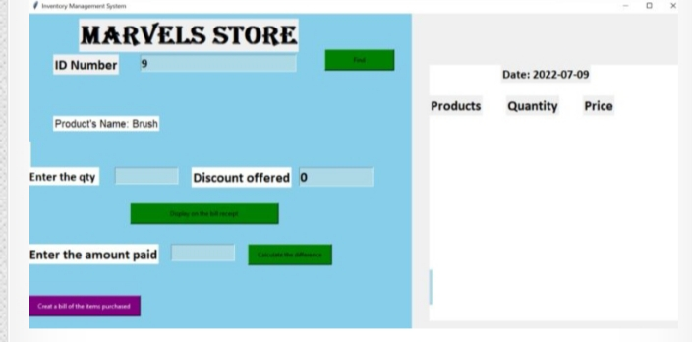

Function for add to cart and calculate change for inventory management:

def add_to_cart(self,*args,**kwargs):

self.quantity_value=int(self.quantity_e.get())

if self .quantity_value >int(self.get_stock):

tkinter.messagebox.showinfo("Error","Not that any products in our stock.")

else:

#calculate the price first

self.final_price=(float(self.quantity_value) * float(self.get_price))-(float(self.discount_e.get()))

products_list.append(self.get_name)

product_price.append(self.final_price)

product_quantity.append(self.quantity_value)

product_id.append(self.get_id)

self.x_index=0

self.y_index=100

self.counter=0

for self.p in products_list:

self.tempname=Label(self.right,text=str(products_list[self.counter]),font=('arial 18 bold'),bg='gray',fg='white')

self.tempname.place(x=0,y=self.y_index)

self.tempqt = Label(self.right, text=str(product_quantity[self.counter]), font=('arial 18 bold'), bg='gray', fg='white')

self.tempqt.place(x=150, y=self.y_index)

self.tempprice = Label(self.right, text=str(product_price[self.counter]), font=('arial 18 bold'), bg='gray', fg='white')

self.tempprice.place(x=300, y=self.y_index)

self.y_index+=40

self.counter+=1

#total confugure

self.total_l.configure(text="Final amount=Rs. "+str(sum(product_price)),bg='gray',fg='white',font=('20'))

self.total_l.place(x=180,y=450)

#delete

self.quantity_e.place_forget()

self.discount_l.place_forget()

self.discount_e.place_forget()

self.productname.configure(text="")

self.pprice.configure(text="")

self.add_to_cart_btn.destroy()

#autofocus to the enter id

self.enteride.focus()

self.quantityl.focus()

self.enteride.delete(0,END)

def change_func(self,*args,**kwargs):

self.amount_given=float(self.change_e.get())

self.our_total=float(sum(product_price))

self.to_give=self.amount_given-self.our_total

#label change

self.c_amount=Label(self.left,text="Change is Rs. "+str(self.to_give),font=('Calibri 20 bold'),fg='Black',bg='white')

self.c_amount.place(x=0 ,y=500)

def generate_bill(self,*args,**kwargs):

self.mycursor.execute("SELECT * FROM inventory WHERE id=%s",[self.get_id])

self.pc = self.mycursor.fetchall()

for r in self.pc:

self.old_stock=r[2]

for i in products_list:

for r in self.pc:

self.old_stock = r[2]

self.new_stock=int(self.old_stock) - int(self.quantity_value)

#updating the stock

self.mycursor.execute("UPDATE inventory SET stock=%s WHERE id=%s",[self.new_stock,self.get_id])

self.conn.commit()

#inster into transcation

self.mycursor.execute("INSERT INTO transaction (product_name,quantity,amount,date) VALUES(%s,%s,%s,%s)",[self.get_name,self.quantity_value,self.get_price,date])

self.conn.commit()

print("Decreased")tkinter.messagebox.showinfo("successfully done")

**OUTPUT**

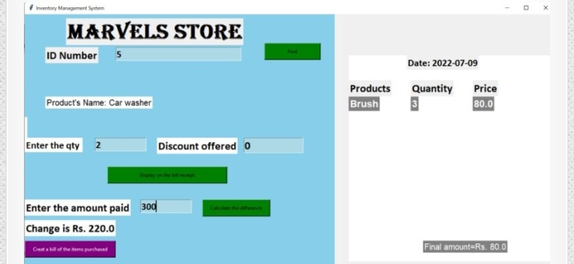

**Creating the form for adding the data in the database of the inventory table:** class Database:

def __init__(self,master,*args,**kwargs):

self.master=master

self.heading=Label(master,text="Add the Details in Database",font=('arial 40 bold'),fg='Red')

self.heading.place(x=250,y=0)

#lables for the window

self.name_l=Label(master,text="Whats the product",font=('Calibri 20 bold'))

self.name_l.place(x=0,y=100)

self.stock_l=Label(master,text="What are the stocks",font=('Calibri 20 bold'))

self.stock_l.place(x=0,y=180)

self.cp_l = Label(master, text="Please enter the price ", font=('Calibri 20 bold'))

self.cp_l.place(x=0, y=260)

#enteries for window

self.name_e=Entry(master,width=25,font=('Calibri 20 bold'))

self.name_e.place(x=380,y=100)

self.stock_e = Entry(master, width=25, font=('Calibri 20 bold'))

self.stock_e.place(x=380, y=180)

self.cp_e = Entry(master, width=25, font=('Calibri 20 bold'))

self.cp_e.place(x=380, y=260)

#button to add to the database

self.btn_add=Button(master,text='Update the database',width=30,height=3,bg='Lightgreen',fg='Black',command=self.get_items,font=2)

self.btn_add.place(x=800,y=100)

self.btn_clear=Button(master,text="Reset the fields",width=30,height=3,bg='Orange',fg='Black',command=self.clear_all,font=2)

self.btn_clear.place(x=800,y=180)

#text box for the log

self.tbBox=Text(master,width=50,height=10)

self.tbBox.place(x=50,y=420)

self.tbBox.insert(END,"ID number:"+str(id))

self.master.bind('<Return>', self.get_items)

self.master.bind('<Up>', self.clear_all)

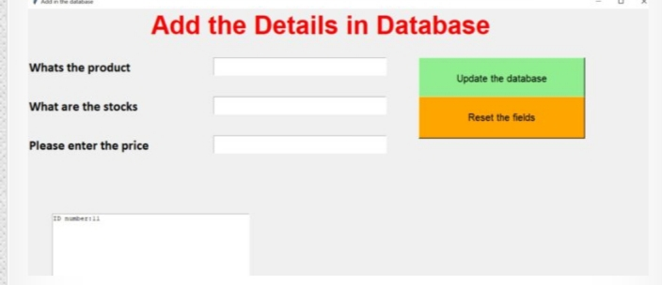

**Function for accepting the data and clearing the text fields:**

def get_items(self, *args, **kwargs):

# get from entries

self.name = self.name_e.get()

self.stock = self.stock_e.get()

self.cp = self.cp_e.get()

# dynamic entries

if self.name == '' or self.stock == '' or self.cp == '':

tkinter.messagebox.showinfo("Error", "Please Fill all the entries.")

else:

mycursor.execute("INSERT INTO inventory(name, stock, price) VALUES(%s,%s,%s)",[self.name,self.stock,self.cp])

conn.commit()

# textbox insert

self.tbBox.insert(END, "\n\nInserted " + str(self.name) + " into the database with the quantity of " + str(self.stock))

tkinter.messagebox.showinfo("Success", "Successfully added to the database")

def clear_all(self, *args, **kwargs):

num = id + 1

self.name_e.delete(0, END)

self.stock_e.delete(0, END)

self.cp_e.delete(0, END)

**OUTPUT**

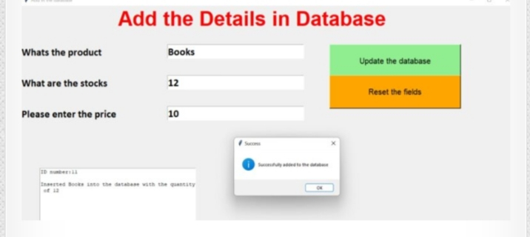

**Create a form of updating the inventory management system:**

class Database:

def __init__(self,master,*args,**kwargs):

self.master=master

self.heading=Label(master,text="DATABASE UPDATION",font=('arial 40 bold'),fg='Red')

self.heading.place(x=400,y=0)

#label and entry for id

self.id_le=Label(master,text="Please enter the ID",font=('Calibri 20 bold'))

self.id_le.place(x=0,y=100)

self.id_leb=Entry(master,font=('Calibri 20 bold'),width=10)

self.id_leb.place(x=380,y=100)

self.btn_search=Button(master,text="Search",width=15,height=2,bg='Blue',command=self.search)

self.btn_search.place(x=550,y=100)

#lables for the window

self.name_l=Label(master,text="What's the product",font=('Calibri 20 bold'))

self.name_l.place(x=0,y=180)

self.stock_l=Label(master,text="How much is the stock",font=('Calibri 20 bold'))

self.stock_l.place(x=0,y=260)

self.cp_l = Label(master, text="Please enter the price ", font=('Calibri 20 bold'))

self.cp_l.place(x=0, y=340)

#enteries for window

self.name_e=Entry(master,width=25,font=('Calibri 20 bold'))

self.name_e.place(x=380,y=180)

self.stock_e = Entry(master, width=25, font=('Calibri 20 bold'))

self.stock_e.place(x=380, y=260)

self.cp_e = Entry(master, width=25, font=('Calibri 20 bold'))

self.cp_e.place(x=380, y=340)

#button to add to the database

self.btn_add=Button(master,text='Fill in the database',width=30,height=2,bg='SkyBlue',fg='black',command=self.update,font=2)

self.btn_add.place(x=400,y=400)

class Database:

def __init__(self,master,*args,**kwargs):

self.master=master

self.heading=Label(master,text="DATABASE UPDATION",font=('arial 40 bold'),fg='Red')

self.heading.place(x=400,y=0)

#label and entry for id

self.id_le=Label(master,text="Please enter the ID",font=('Calibri 20 bold'))

self.id_le.place(x=0,y=100)

self.id_leb=Entry(master,font=('Calibri 20 bold'),width=10)

self.id_leb.place(x=380,y=100)

self.btn_search=Button(master,text="Search",width=15,height=2,bg='Blue',command=self.search)

self.btn_search.place(x=550,y=100)

#lables for the window

self.name_l=Label(master,text="What's the product",font=('Calibri 20 bold'))

self.name_l.place(x=0,y=180)

self.stock_l=Label(master,text="How much is the stock",font=('Calibri 20 bold'))

self.stock_l.place(x=0,y=260)

self.cp_l = Label(master, text="Please enter the price ", font=('Calibri 20 bold'))

self.cp_l.place(x=0, y=340)

#enteries for window

self.name_e=Entry(master,width=25,font=('Calibri 20 bold'))

self.name_e.place(x=380,y=180)

self.stock_e = Entry(master, width=25, font=('Calibri 20 bold'))

self.stock_e.place(x=380, y=260)

self.cp_e = Entry(master, width=25, font=('Calibri 20 bold'))

self.cp_e.place(x=380, y=340)

#button to add to the database

self.btn_add=Button(master,text='Fill in the database',width=30,height=2,bg='SkyBlue',fg='black',command=self.update,font=2)

self.btn_add.place(x=400,y=400)

**OUTPUT**

